5.5 Multiplying & Dividing a Polynomial by a Constant Name:
Focus: Date:

Part A: Multiplication

Suppose Isabel had a basket of 3 apples and 4 bananas:
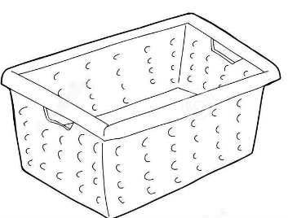

If Eric had ___________________ as many as Isabel, how many apples and bananas would he have?

General Rule:

Part B: Examples:

Ex.1) Determine each product.

Part C: Division

General Rule:

Part D: Examples

Ex.2) Find each quotient.

