ASL Club – Lesson #1
Topics:
- Question vs Statement
- Feelings
- How much of something (ex. A little, a lot)

Dialogue:

A: Hi, my name is _____________. What’s yours?
B: My name is __________. Are you deaf or hearing?

A: I’m hearing. And you?
B: I’m hearing.

A: How are you?
B:
- I’m happy! I have no homework this weekend.
- I’m fine. I have a little bit of homework this weekend.
- I’m sad. I have some homework this weekend.
- I’m mad. I have a lot of homework this weekend.

Notes:

Vocabulary:

Name | Deaf  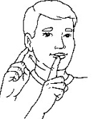 | Hearing  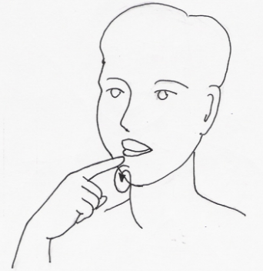
Happy | Fine | Sad | Mad
No (not)  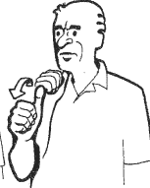 | A little | Some | A lot  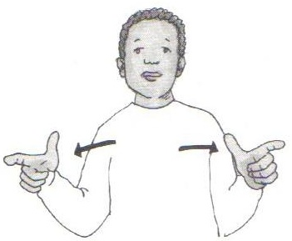
Have  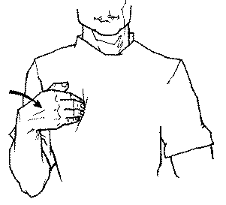 | Homework  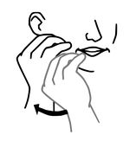  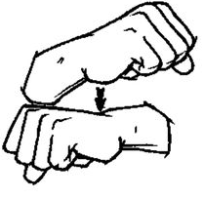 | Weekend

