ASL Club – Lesson #2
Topics:
- Greetings
- Numbers
- Time
- Day, week, month, year (single/multiple)

Dialogue:

A: Hi! Good
- Morning
- Afternoon
- Night
B: Hi! Good
- Morning
- Afternoon
- Night

A: How are you?
B: I’m tired. I studied for
- 1 month
- 2 weeks
- 5 days

B: And you?
A: I’m not tired. I studied for
- 2 hours
- 20 minutes
- 10 seconds

Vocabulary:

Good | Morning  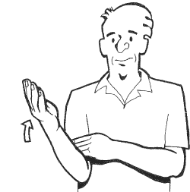 | Afternoon | Night
Second | Minute | Hour | Time  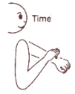
Study | Tired  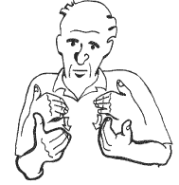

Time-Sensitive:
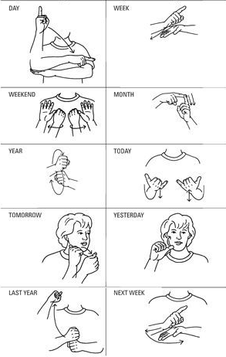

Numbers:
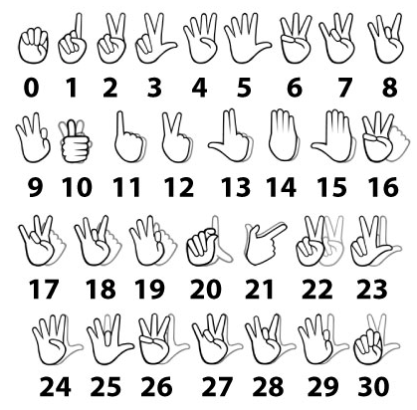

W-Questions:

