ASL Club – Lesson #3
Topics:
- Review Introduction
- Meet a deaf person
- Help a stranger
- Who, what, where, when, how?

Dialogue:
Part A: Review
A: Hi! Good morning. How are you?
B: I’m fine. How are you?
A: I’m tired. I studied for 5 hours.

A: What’s your name?
B: My name is __________. And yours?
A: My name is __________.

Part B: Meeting a Deaf Person
A: Are you deaf or hearing?
B: I’m hearing. And you?
A: I’m hearing too.

A: How do you know sign language?
B: My brother is deaf. And you?
A: I’m learning it at school.

B: You sign well.
A: Thank you. But can you please slow down? I don’t understand.
B: Ok, sorry.

Part C: Helping a Stranger
A: Excuse me, do you need help?
B: Yes, thank you. Where is there a restaurant?

A: There are many restaurants around this neighbourhood. What do you like to eat?
B: I like:
- Hamburger
- Sushi
- Spaghetti
A: You go 1 block then turn right.

A: Can you tell me where the hospital is?
B: You go 5 blocks then turn left. Why are you going? Who are you seeing?
A: I’m seeing my grandmother.
B: When are you going?
A: I’m going
- Now
- Later

Vocabulary:
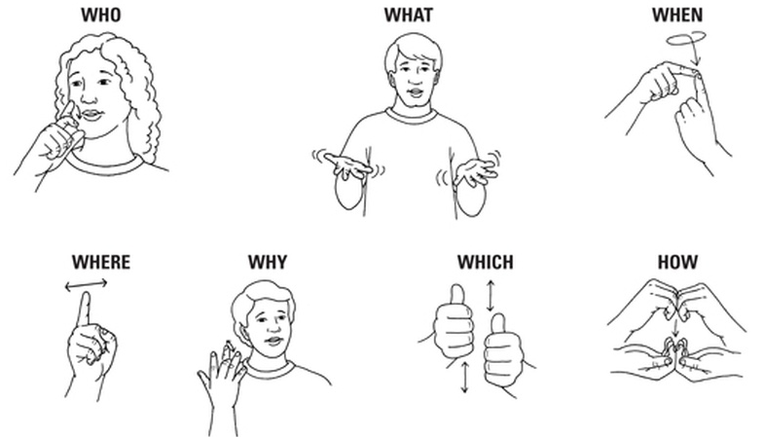

Restaurant  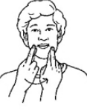 | Hospital  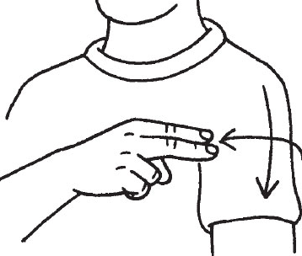 | Help  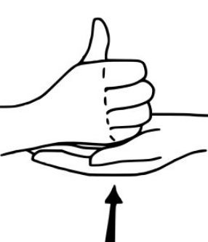 | Understand  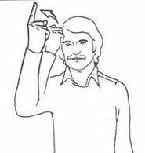
Hamburger  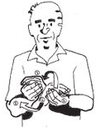 | Sushi  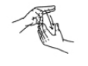 | Spaghetti  