ASL Club – Lesson #4
Topics:
- Family members
- Review Numbers
- Age

Dialogue:
Part A: Review
A: Hi! How are you?
B: Hi! I haven’t seen you in awhile! Nice to see you!
A: Nice to see you too!

Part B: Family
A: Do you have siblings?
B: I have ______________________.

B: And you?
A: I have ______________________.

Part C: Places
A: Do your grandparents live here?
B: They live in Vancouver. Where do your grandparents live?

B: Where do your grandparents live?
A: They live in Calgary.

Vocabulary:
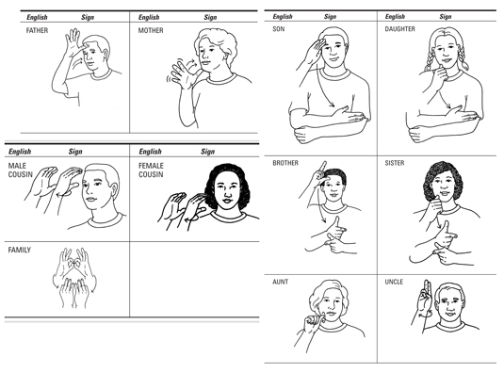

Age/How old?  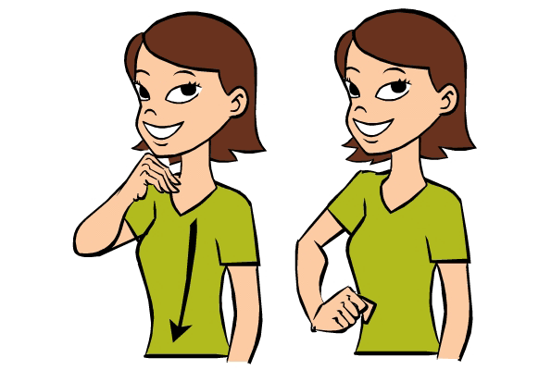 | How many?  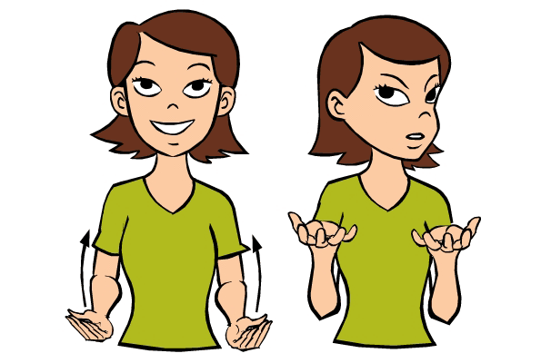
Where do you live?
