ASL Club – Lesson #5
Topics:
- Review
- Noun versus Verb
- Verb + Agent
- Placement

Dialogue:
Part A:
A: Hi! How are you?
B: Hi! I’m fine. And you.
A: I’m tired. I studied for a long time!

A: Are you deaf or hearing?
B: I’m hearing.
A: How do you know ASL?
B: I’m studying ASL. How do you know ASL.
A: My brother is deaf.

A: I have (number) brothers and (number) sisters.
B: I have (number) brothers and (number) sisters.

Vocabulary:

Teach | Learn | Work  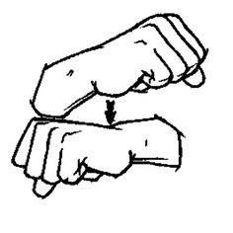 | Sell  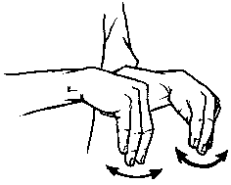
Fly  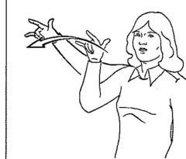 | Write  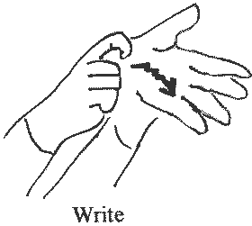 | Runner

