Lesson #5 - Scale Diagrams & Reductions Name:
Focus: Date:

Part A: Introduction

Part B: Examples
- Determine the scale factor for each reduction as a fraction or decimal.
- b)
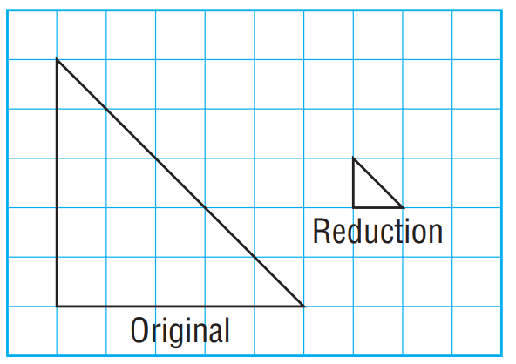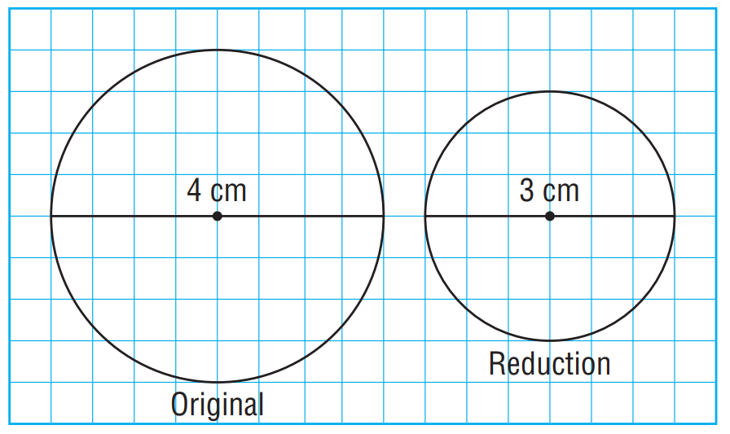

Learning Goal: | Beginning | Progressing | Achieving | Excelling
I can find the scale factor
Ex.2) A reduction of each object is to be drawn with the given scale factor. Determine the corresponding length in centimetres on the scale diagram.
- A bicycle has a wheel with diameter about 60 cm. The scale factor is$\frac{3}{50}$.

- A sailboat has length 8 m. The scale factor is 0.02.

Learning Goal: | Beginning | Progressing | Achieving | Excelling
I can find the corresponding length on scale diagram

Ex.3) Which of rectangles A, B, and C is a reduction of the large rectangle? Show work.

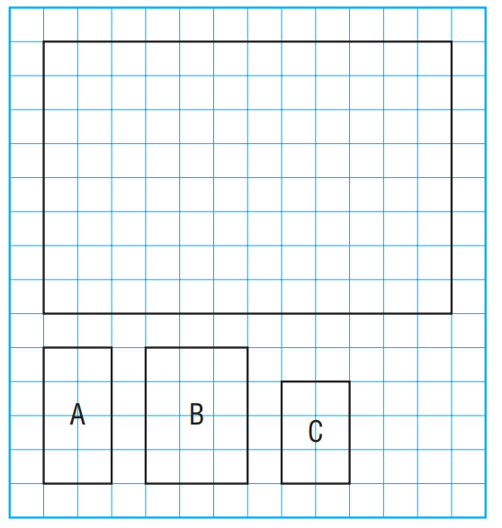
Learning Goal: | Beginning | Progressing | Achieving | Excelling
I can justify a reduction

Ex.4) Here is a scale diagram of the top view of a truck. The length of the truck is 4 m.

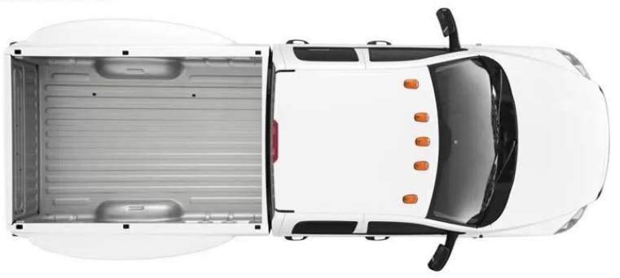 Scale 1:50

- The front and back wheels of the truck are 3.85 m apart. How far apart should the wheels be on the scale diagram?

- What is the width of the truck?

Learning Goal: | Beginning | Progressing | Achieving | Excelling
I can calculate given a scale

Ex.5) Which two polygons have pairs of corresponding lengths that are proportional? Identify the scale factor for the reduction.
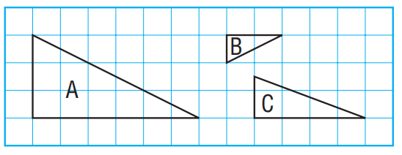

Learning Goal: | Beginning | Progressing | Achieving | Excelling
I can find proportion
Ex.6) Draw a scale diagram of this octagon. Use a scale factor of 0.25.

