#1

Change to decimals:

1. 
2. 
3. 
4. 

#2

Determine whether it is a rational number or irrational number. Explain.

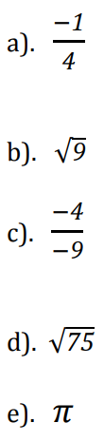

#3

Use or = to determine which rational number is greater.

#4

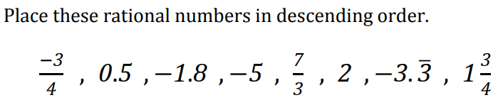

#5

Add integers. Do not use calculator:

1. (-4) + (-5)
2. (-6) + (+1)
3. (+8) + (-2)
4. (+2) + (+5)

#6

Add decimals. Use calculator if needed.



b)



c)



d)



e)



f)



#7

Add Fractions. Do not use calculator:

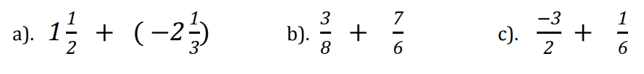

#8

Subtracting Rational Numbers:

a)



b)



c)

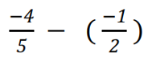

d)

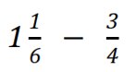

#9

Addition/Subtraction Word Problem:

a)



b)



#10

Multiplying Rational Numbers:

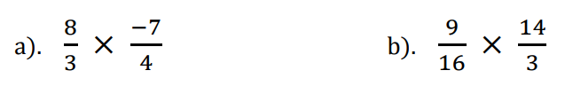

#11

Dividing Rational Numbers:



b)



c)

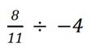

#12

Multiplication/Division Word Problem:



#13

Evaluate using Order of Operation. Do not use calculator.

a)

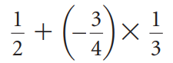

b)

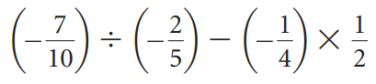

c)

