Solutions:

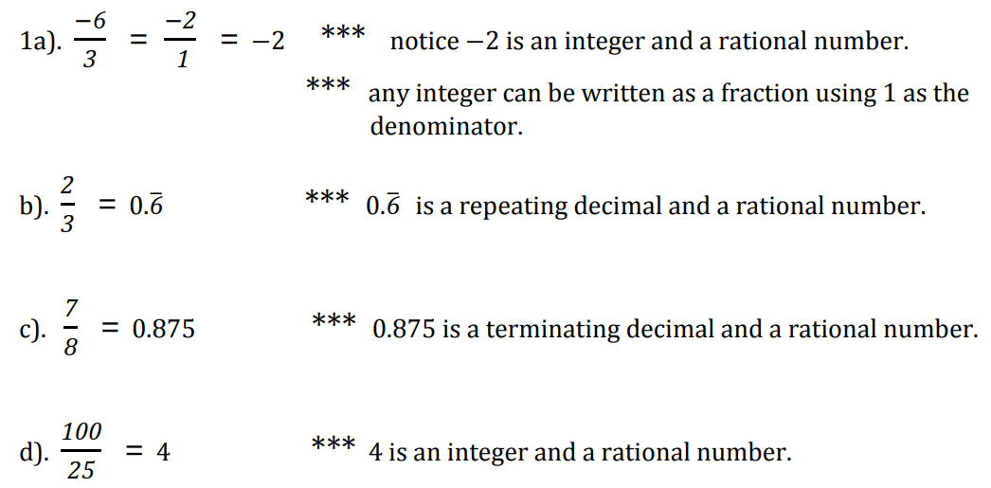
_____________________________________________________________________________________

2)
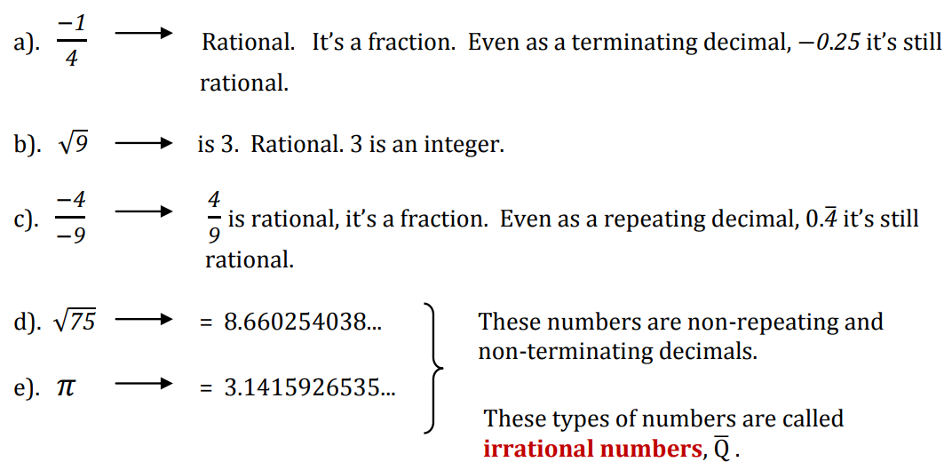
_____________________________________________________________________________________

3)

4)
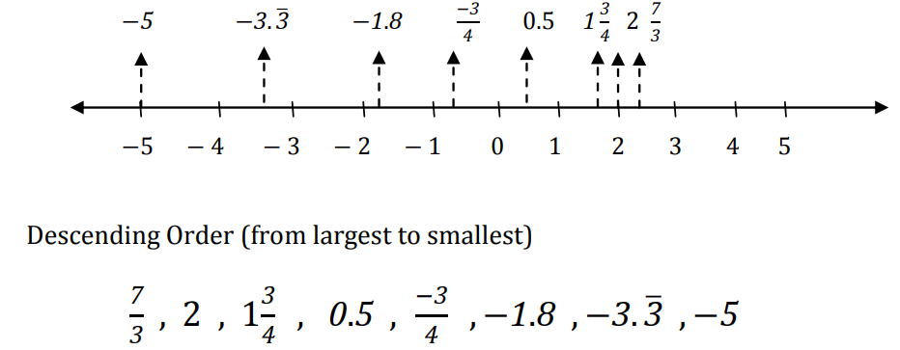
_____________________________________________________________________________________
5) a) -9 b) -5 c) +6 d) +7

_____________________________________________________________________________________
6)

_____________________________________________________________________________________
7)

8)

_____________________________________________________________________________________

9)
a)

b)
_____________________________________________________________________________________

10)

11)

_____________________________________________________________________________________

12)

_____________________________________________________________________________________

13)

