Data Analysis Project Name: _______________________
Mathematics 9
DUE DATE: _______________________

Carrying out research and drawing conclusions require an unbiased question free of influencing factors, appropriate sampling techniques, and an unbiased display of data.

You will organize your research and carry out a plan.

Design a plan to collect data for a survey, collect the data, and represent findings using displays, make conclusions and predictions. To help with the project, you will follow the criteria below; please include this in your report. In the Completed Box, assess your project by: B=beginning, P=Progressing, A=Achieving, E=Excelling.

You should collect data from at least 50 samples. Your group will submit a report and present the project and findings to the class. Please keep the presentation down to 5 minutes.

PART I: PLANNING
Criteria | Things To Think About… | Completed
Write the research question. | Be mindful of bias, wording, timing, privacy, and cultural sensitivity. The question should be free from influencing factors. What considerations did you make when you wrote the question(s)?
Write the prediction.
Describe the population. | If you select a sample, ensure it represents the population.
State your sampling method. Describe how you will collect data. Be sure that instructions are clear. How do you ensure that your findings will be valid? | Choose an appropriate sampling method. To avoid sampling bias, consider whether bias will result from the survey method or from the sample.  Consider the time and cost. Remember, if someone else decides to do the same survey, they will have to follow your instructions.

PART II: PERFORMING & RECORDING
Criteria | Things To Think About… | Completed
Collect and record data. | Use your sampling method.
Describe how you will organize and display your data. | Choose an appropriate display for the data, such as a table, circle graph, bar graph, or line graph.
Describe your method for analyzing the data. | Consider the following ideas:  - Describe any assumptions that were made  - Discuss the accuracy of any predictions made about the population  - Describe how you will present your findings

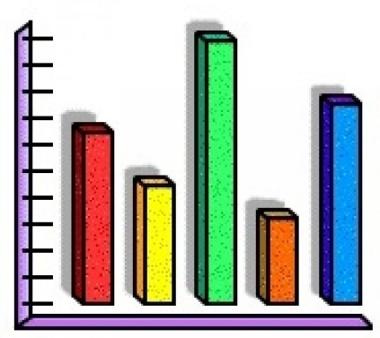

PART III: DISPLAY & ANALYZING
Criteria |  | Completed
Describe your method for analyzing the data. | Were there any assumptions made? Were there any limitations? Discuss the accuracy of any predictions made about the population.
Display your data | Use bar graph or circle graph.
Summarize your findings and draw a conclusion from the data. | Write a conclusion based on your findings. Refer to your graph. How does this compare with your prediction? Are you surprised by the results? Explain. What do you see for the future based on your results?  Who might be interested in your data and why?  If you were to repeat the project, what steps would you take to improve it? Explain.

REPORT
Excelling | Achieving | Progressing | Beginning
Project Design (Part I) is completed. | Project Design (Part I) is mostly completed. | Project Design (Part I) is somewhat completed. | Project Design (Part I) is not completed.
Display of Data is completed. | Display of Data is mostly completed. | Display of Data is somewhat completed. | Display of Data is not completed.
Conclusions is completed. | Conclusions is mostly completed. | Conclusions is somewhat completed. | Conclusions is not completed.
Self-Assessment Rubric is completed. | Self-Assessment Rubric is mostly completed. | Self-Assessment Rubric is somewhat completed. | Self-Assessment Rubric is not completed.
Overall Presentation and Neatness demonstrated. | Overall Presentation and Neatness is mostly demonstrated. | Overall Presentation and Neatness is somewhat demonstrated. | Overall Presentation and Neatness is not demonstrated.
Total:

PRESENTATION

4 | 3 | 2 | 1
All group members participate equally. | All group members participate. | Some group members participate. | Only 1 member participates.
All group members speak clearly and are easy to understand with eye contact. | Most group members speak clearly and are easy to understand with eye contact. | Some group members speak clearly and are easy to understand with eye contact. | Only 1 or no member speaks clearly and is easy to understand with eye contact.
Information is presented in an organized way. | Information is mostly presented in an organized way. | Information is somewhat presented in an organized way. | Information is presented in a disorganized way.
Visuals are informative and organized. | Visuals are mostly informative and organized. | Visuals are somewhat informative and organized. | Visuals are not informative and organized.
Presentation is in a timely matter of 5 minutes. | Presentation is mostly in a timely matter. | Presentation is somewhat in a timely matter. | Presentation is not in a timely matter.
Total:

